How to install the handling robot

Step 1
Dismantle the ultrasonic sensor | 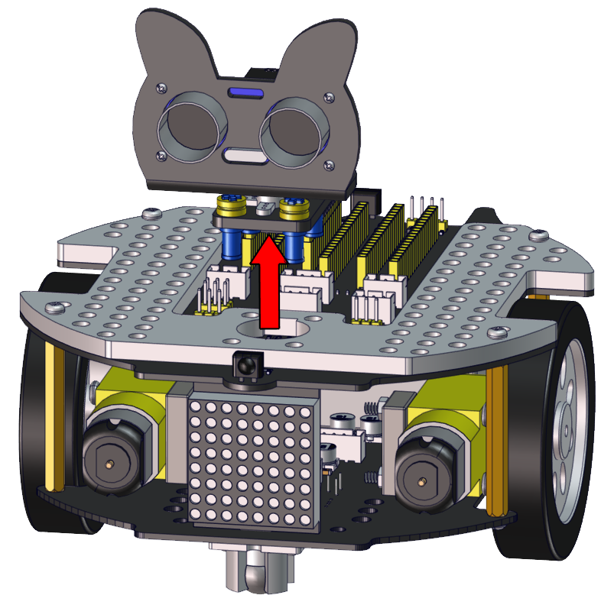
Required components | 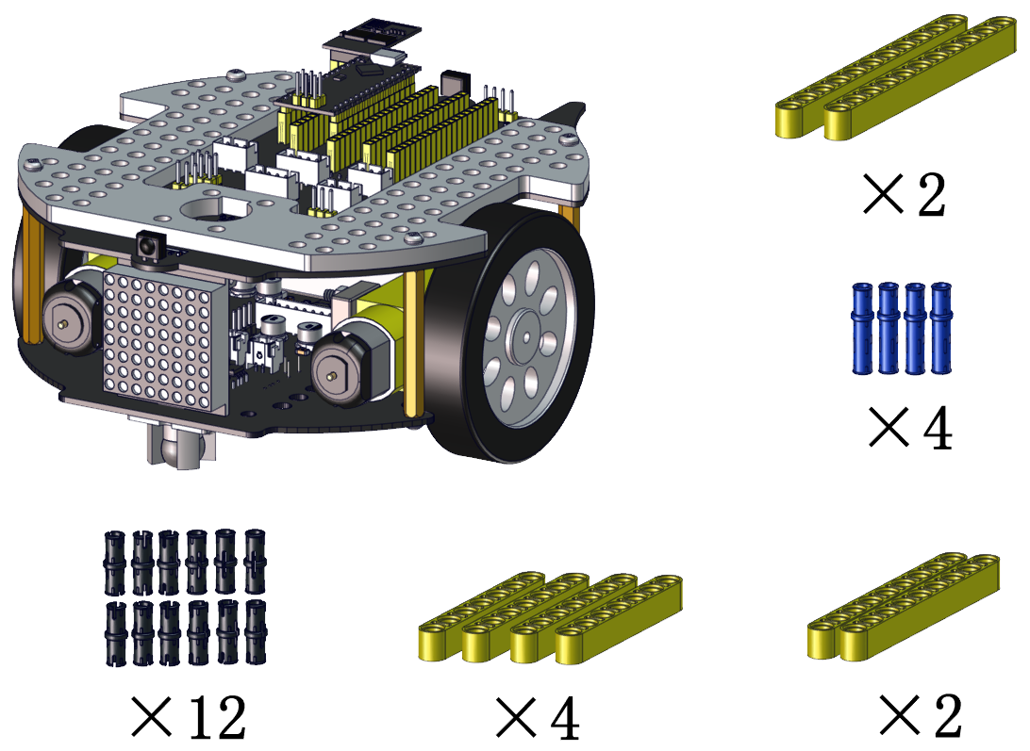

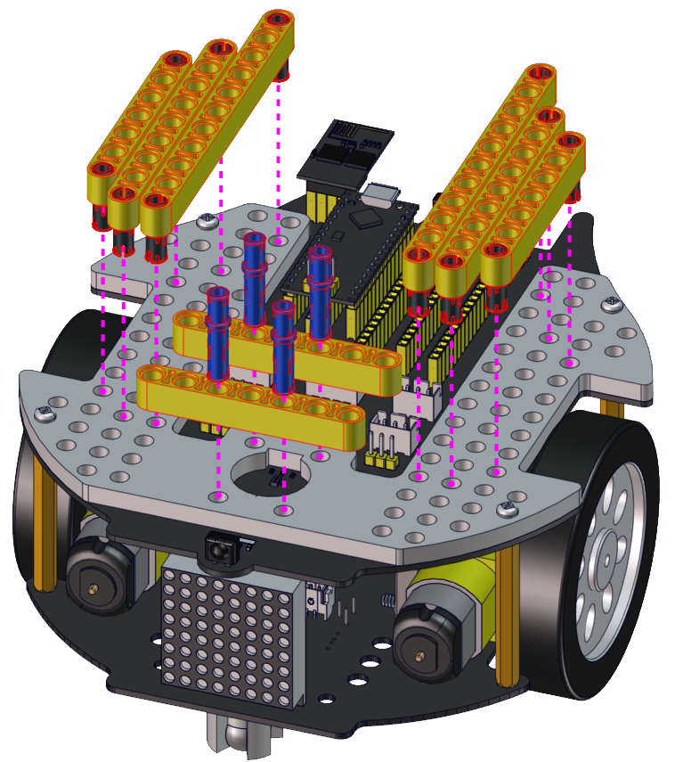

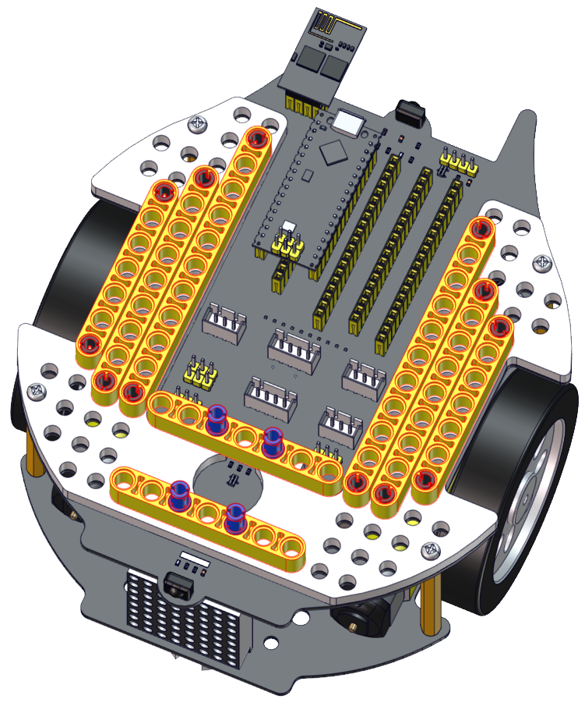

Step 2
Required components | 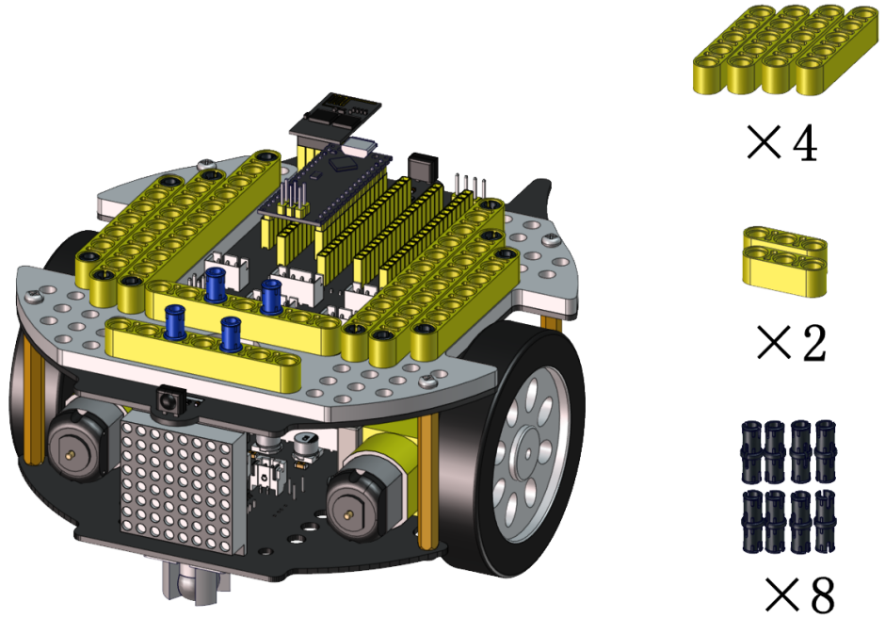

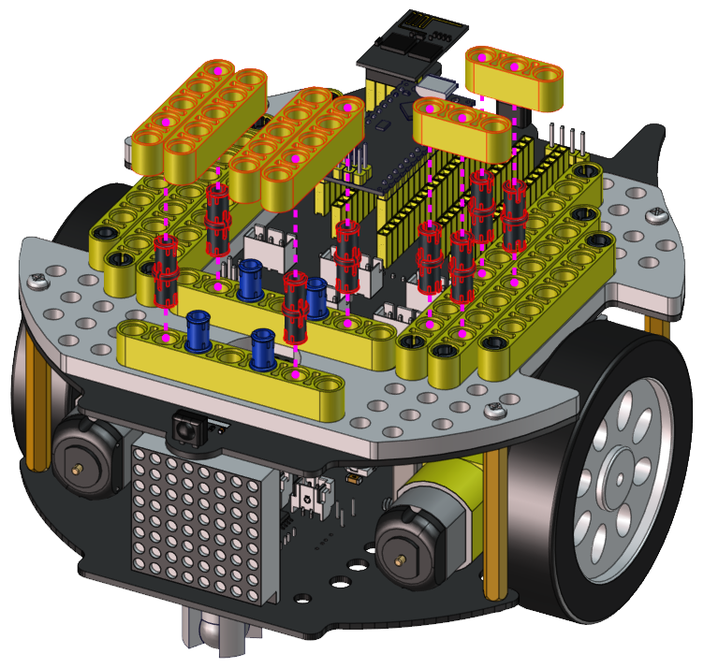

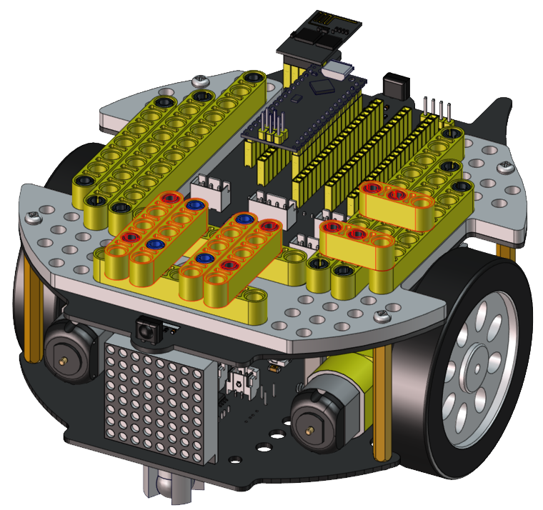

Step 3
Required components | 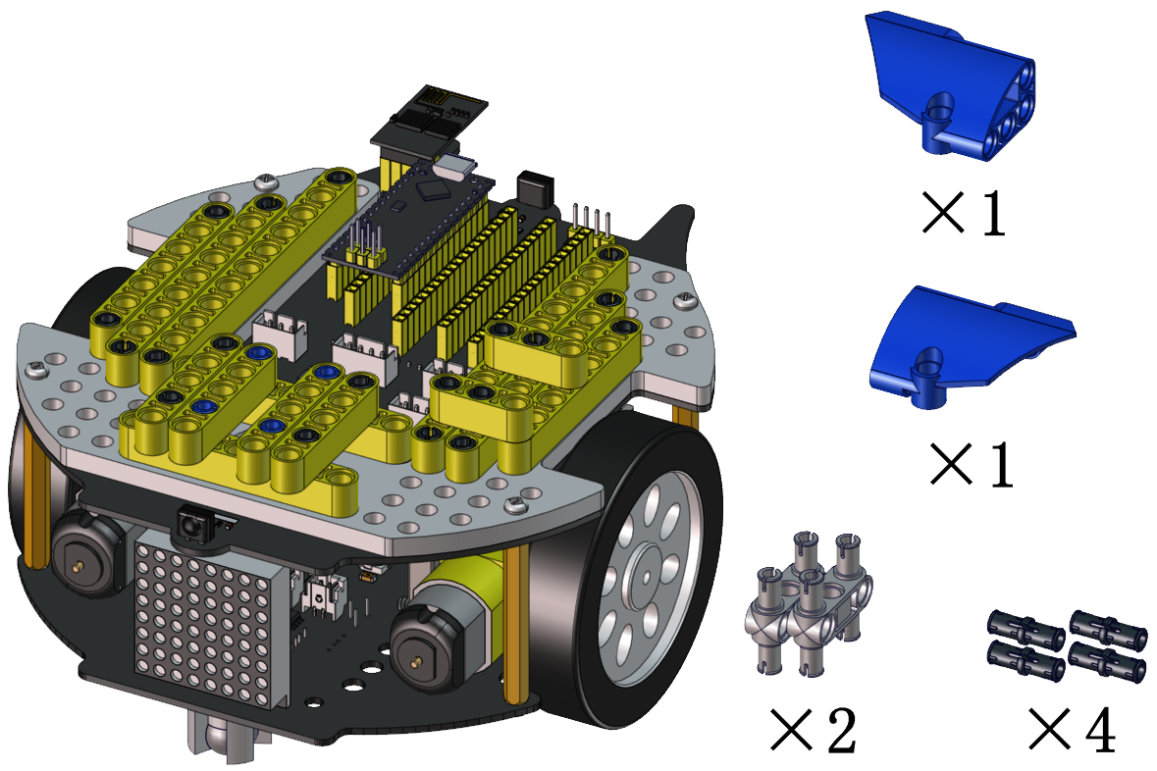

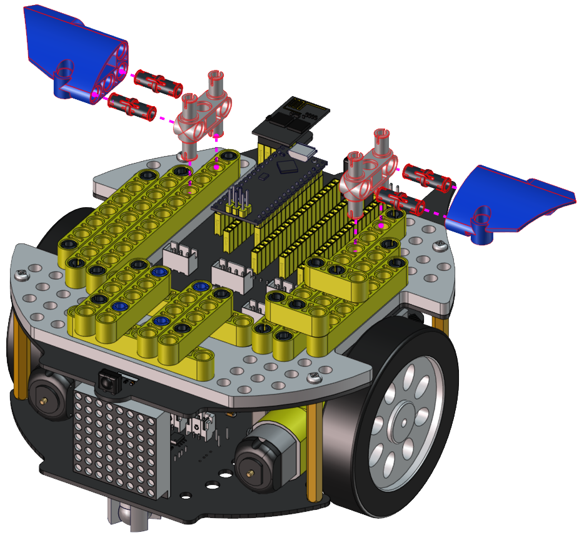

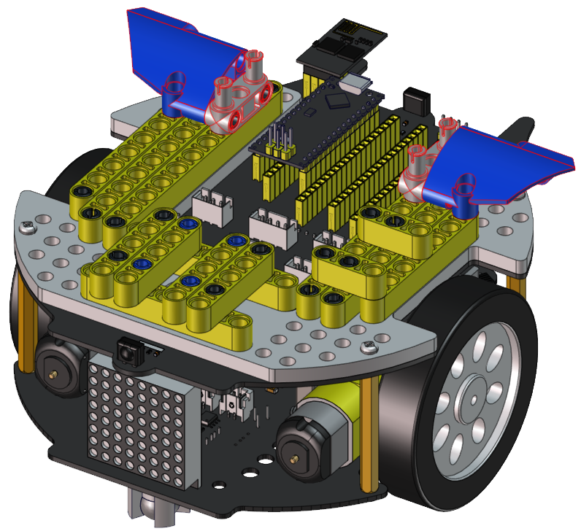

Step 4
Required components | 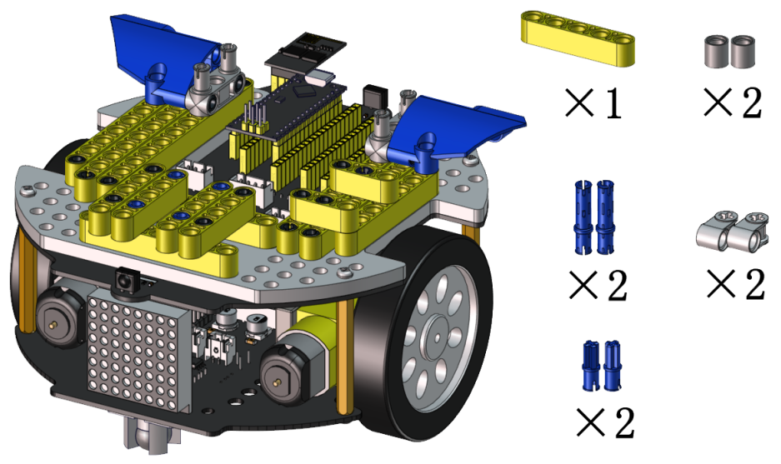

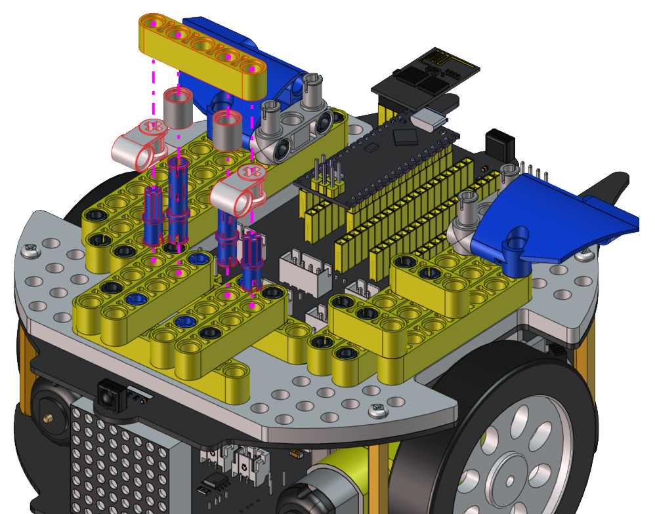

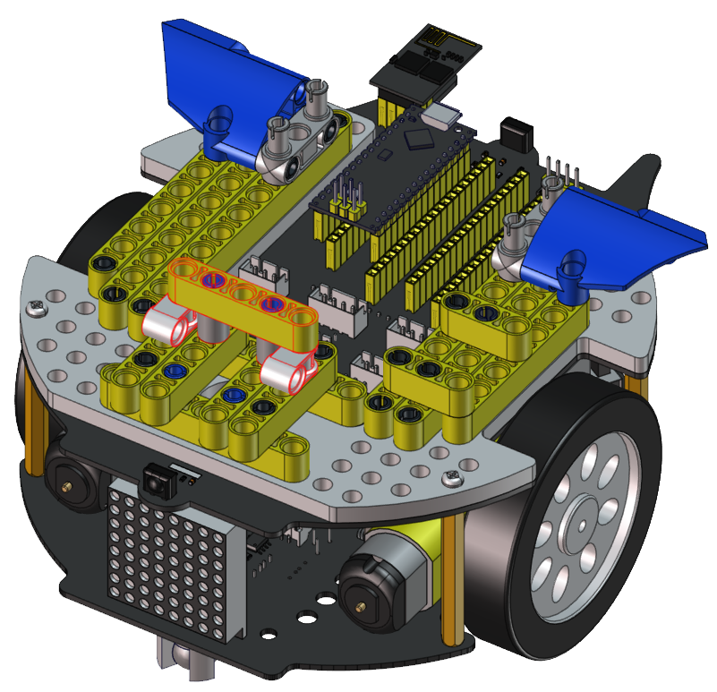

Step 5
Required components | 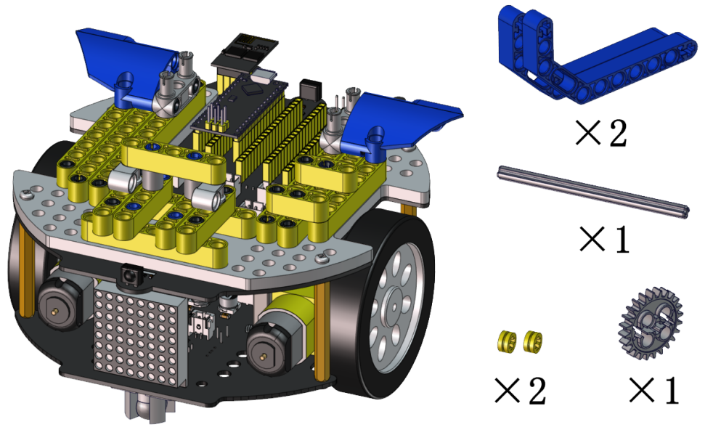

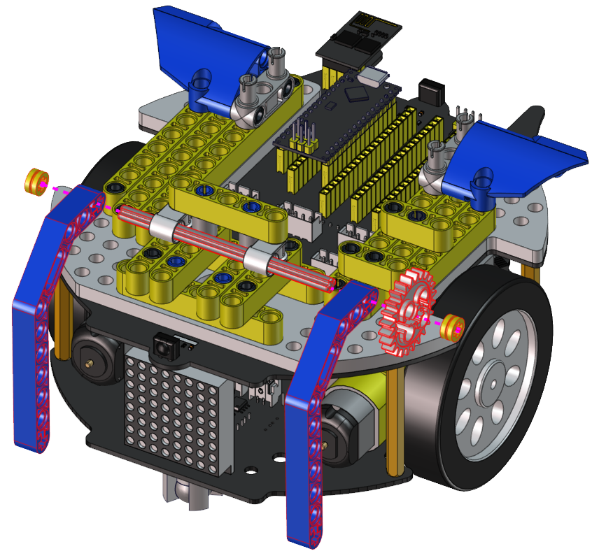

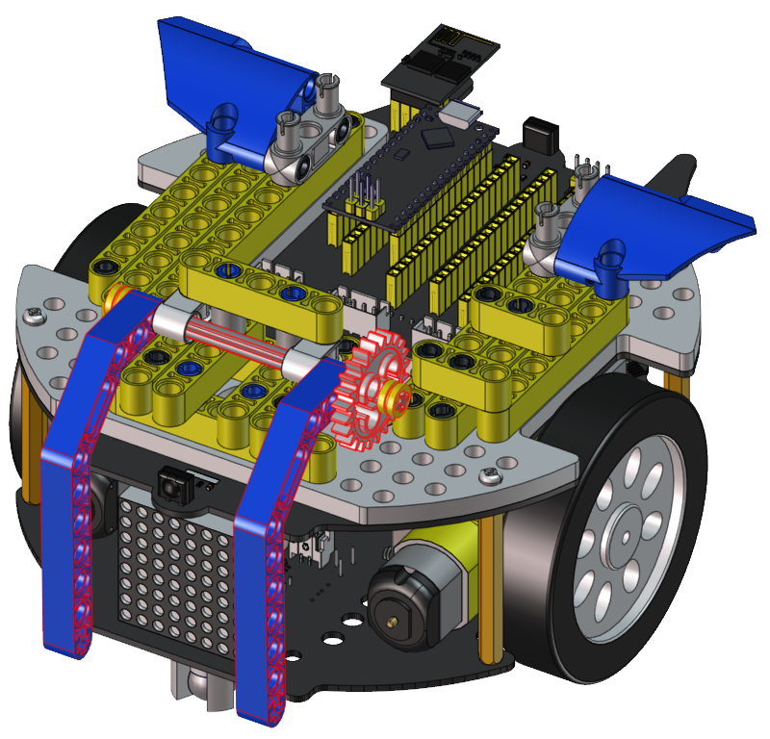

Step 6
Required components | 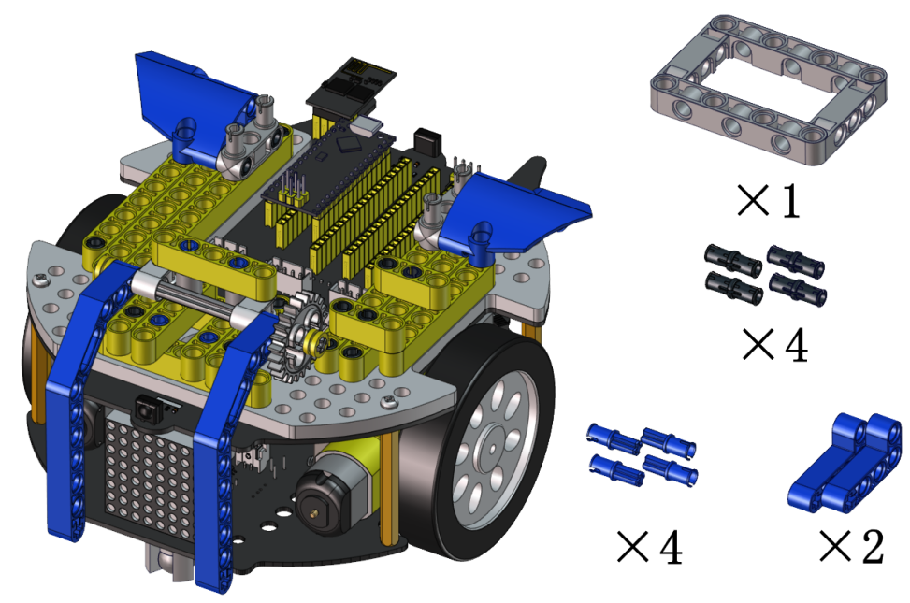
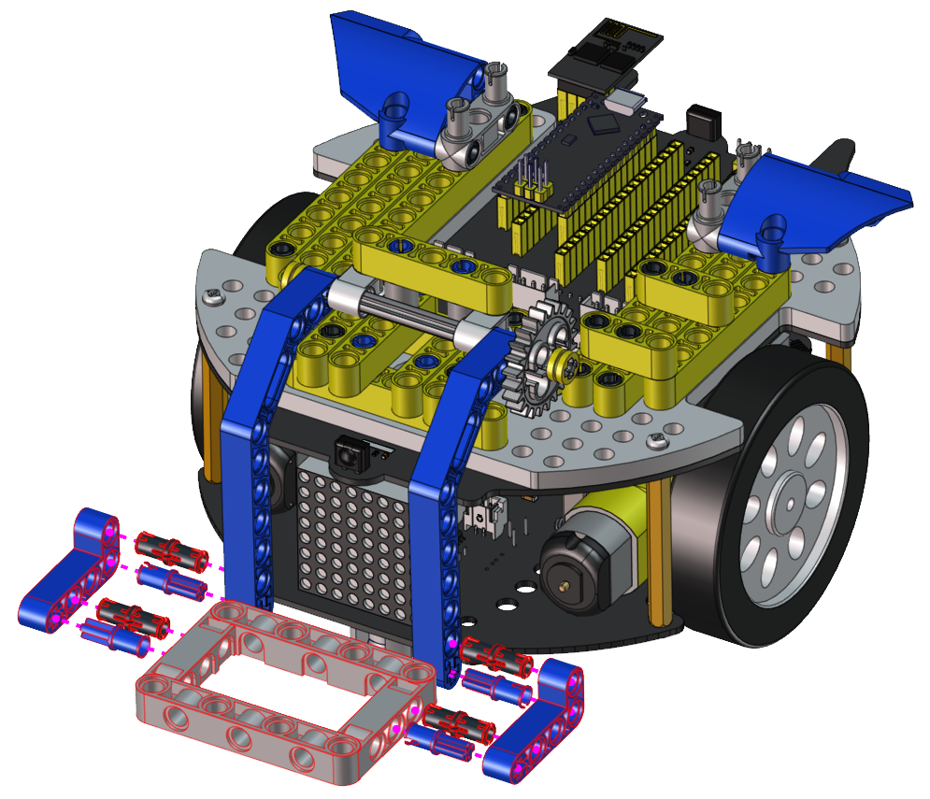

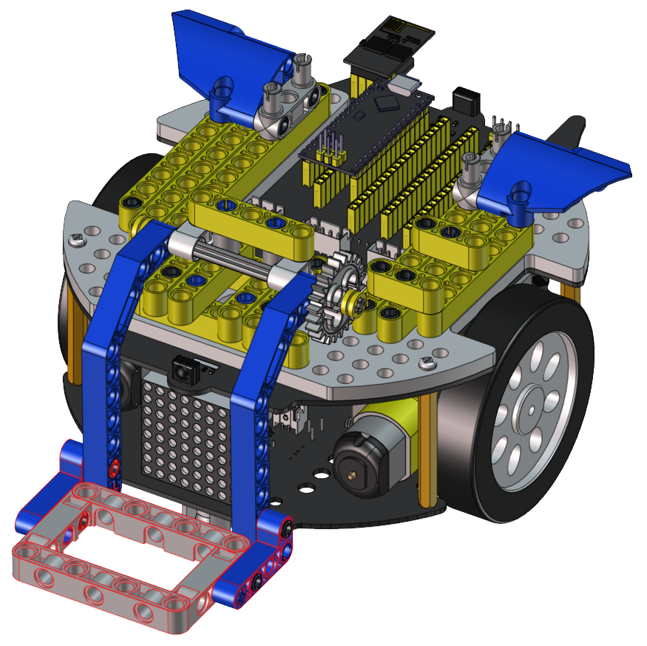

Step 7
Required components | 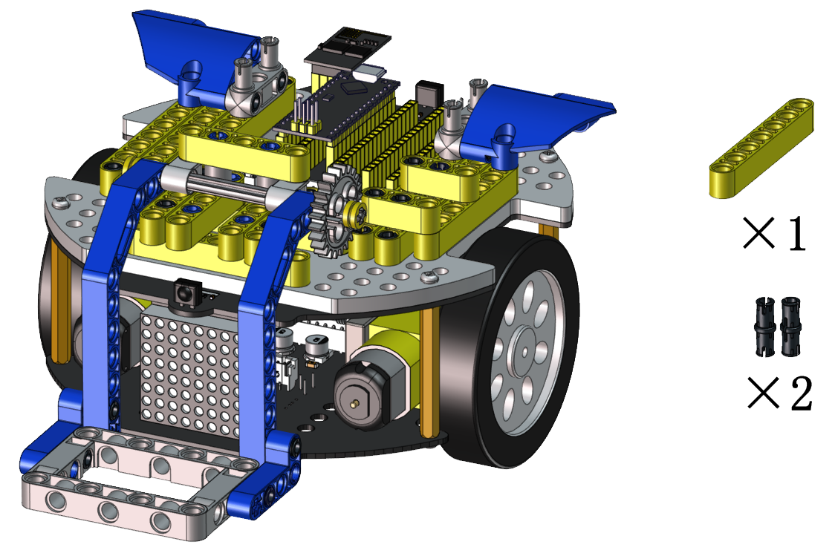

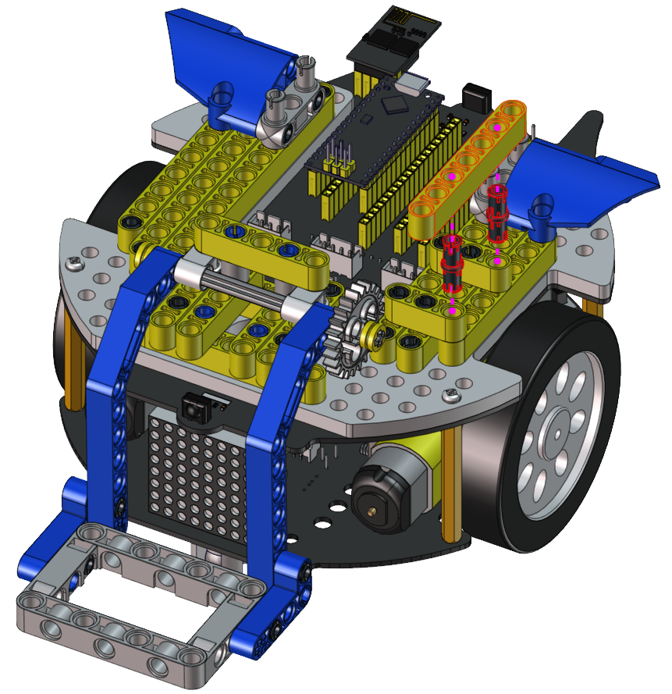

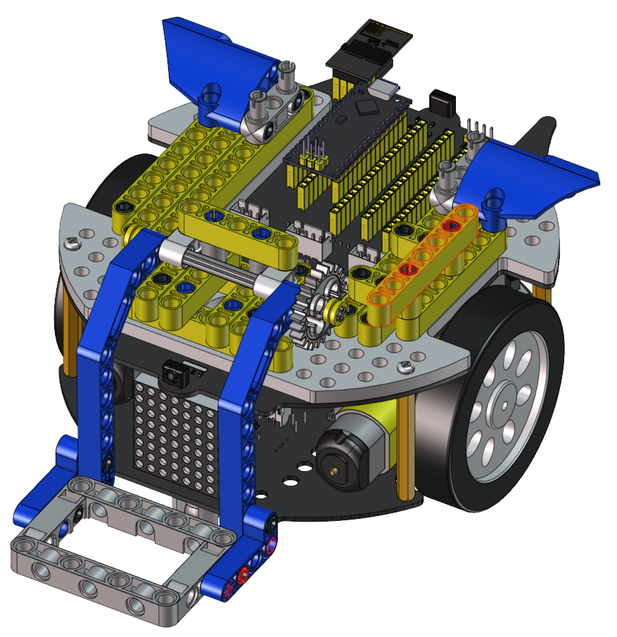

Step 8
Required components | 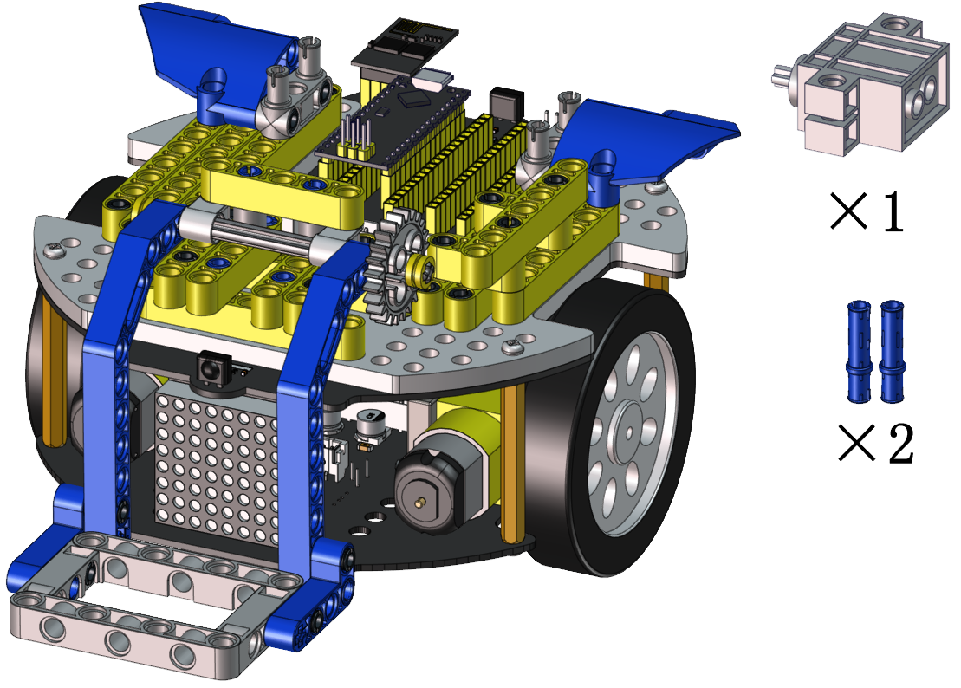

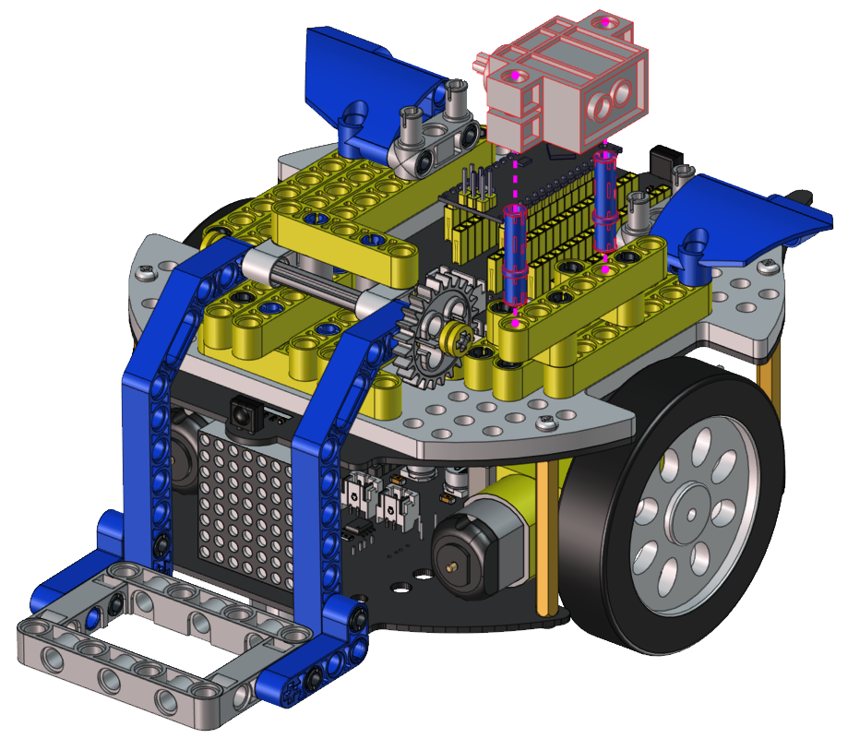

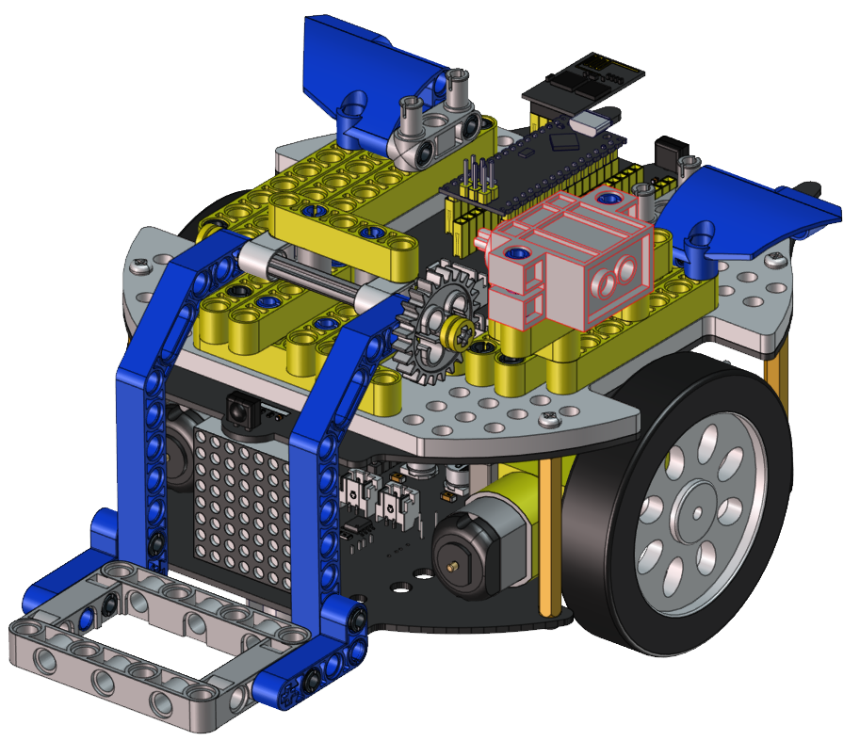

Step 9
Required components | 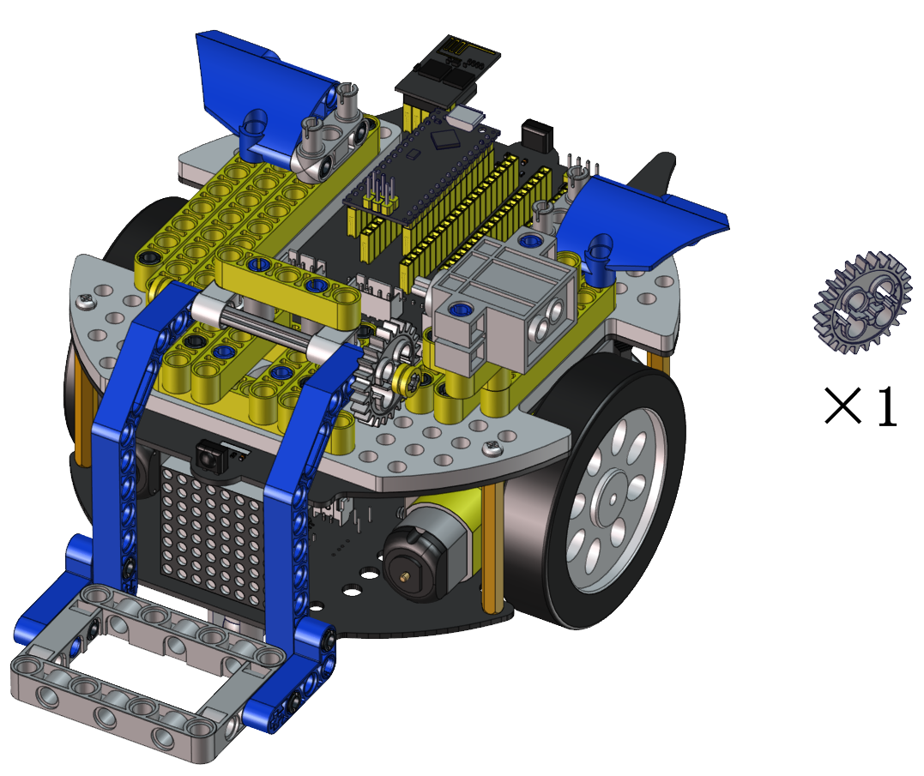
Set the angle of the servo to 180 degree | Wire servo up  //*********************************************************************  #include <Arduino.h>  //Servo channels  int channel_PWM = 4;  // Servo frequency, then the period is 1/50, which is 20ms, PWM has a total of 16 channels, 0-7 high-speed channels are driven by 80Mhz clock, and the last 8 low-speed channels are driven by 1Mhz clock.  int freq_PWM = 50;  // PWM resolution, the value is between 0-20, here is 10, then the pwm value filled in the following ledcWrite is between 0-2 to the 10th power, that is, 0-1024.  int resolution_PWM = 10;  //  const int PWM_Pin = 23; //connect pwm to GPIO23 output.  void setup() {  ledcSetup(channel_PWM, freq_PWM, resolution_PWM); // Set servo channel, servo frequency, PWM resolution..  ledcAttachPin(PWM_Pin, channel_PWM); //  }  void loop() {  ledcWrite(channel_PWM, 128); //The 20ms high level is about 2.5ms, which is 2.5/20*1024, and the angle of the steering gear is 180°.  .  }  //*********************************************************************  Upload the code of the servo to the main board of the Beetlebot car, as shown below  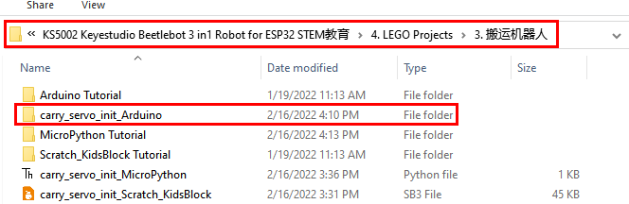  You can also initialize the angle of the servo through the following code  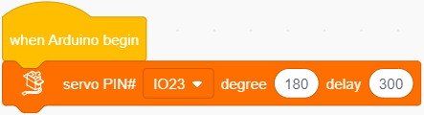  Check the Scratch-KidsBlock code as follows，then upload the code to the main board of the Beetlebot car  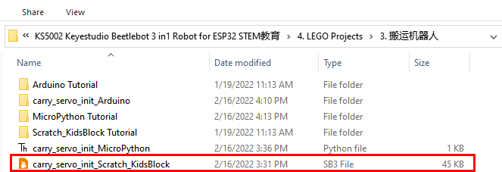
  Servo | PCB Board
  Brown | G
  Red | 5V
  Orange | S2（A0）
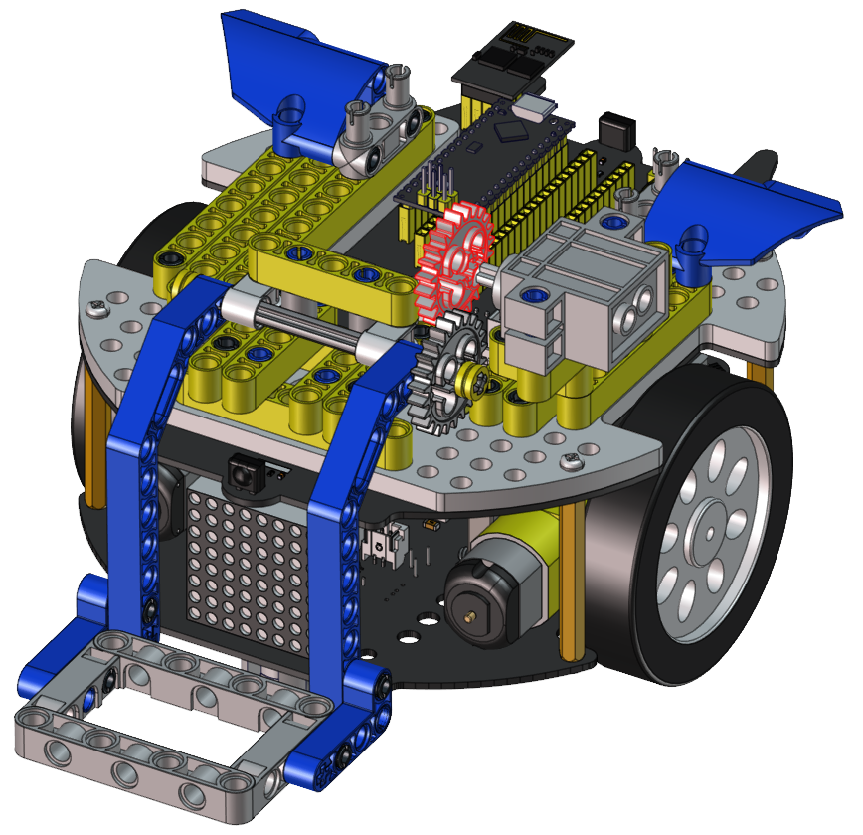

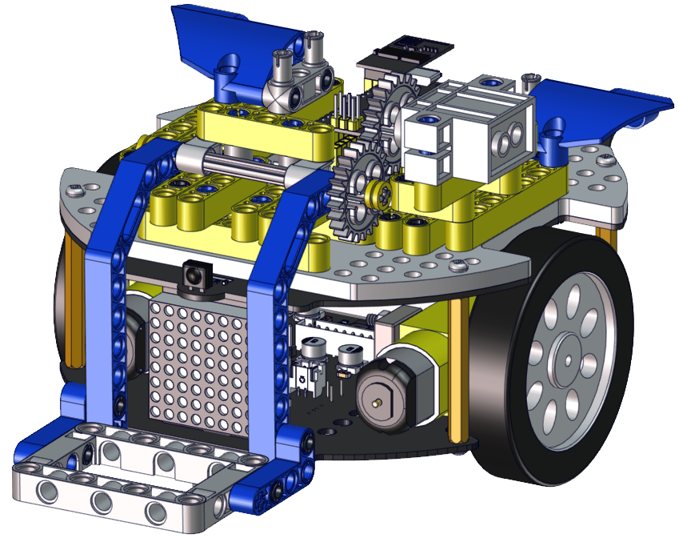

Step 10
Required components | 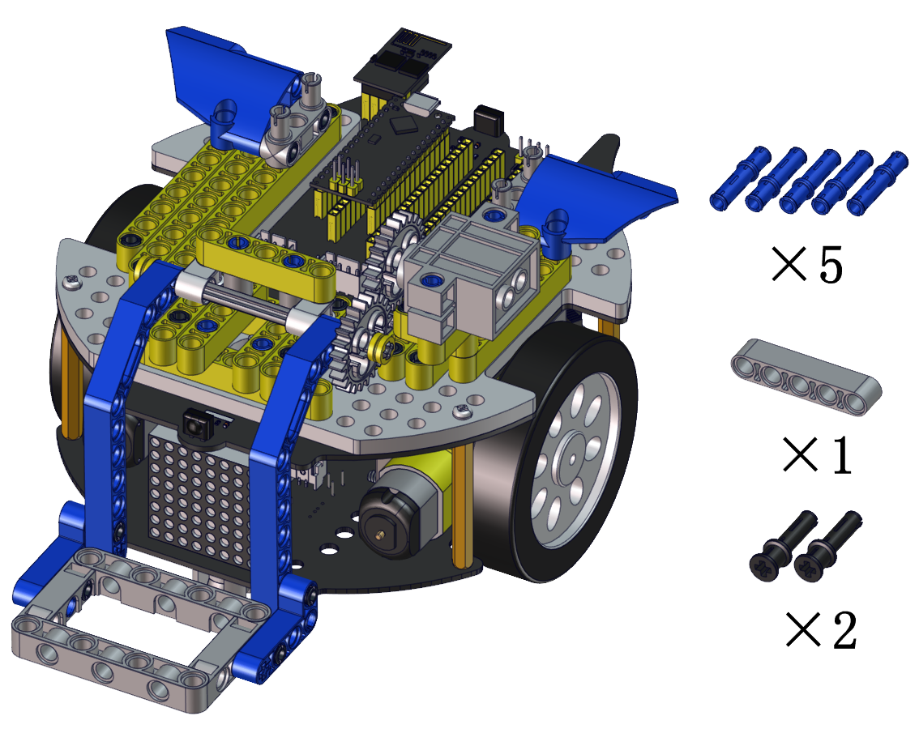

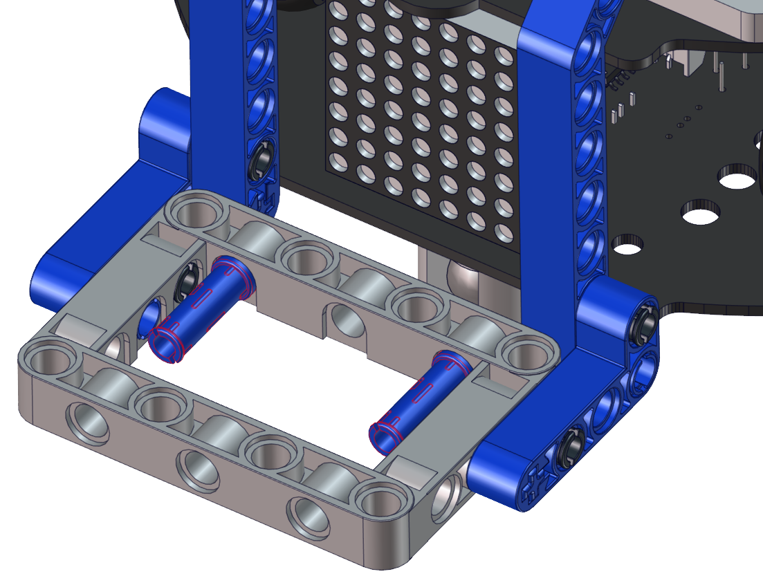

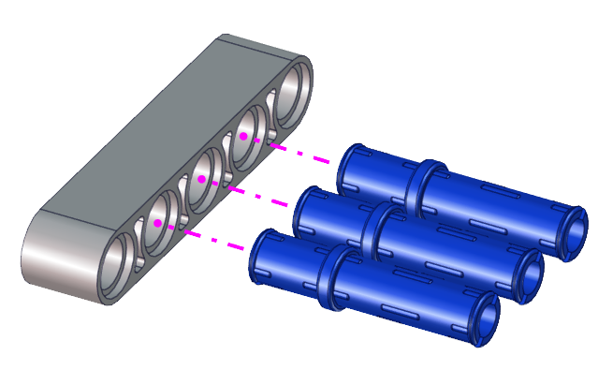

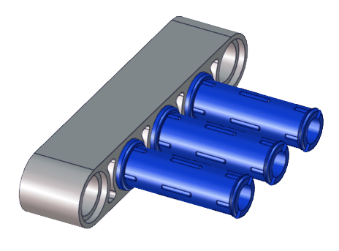

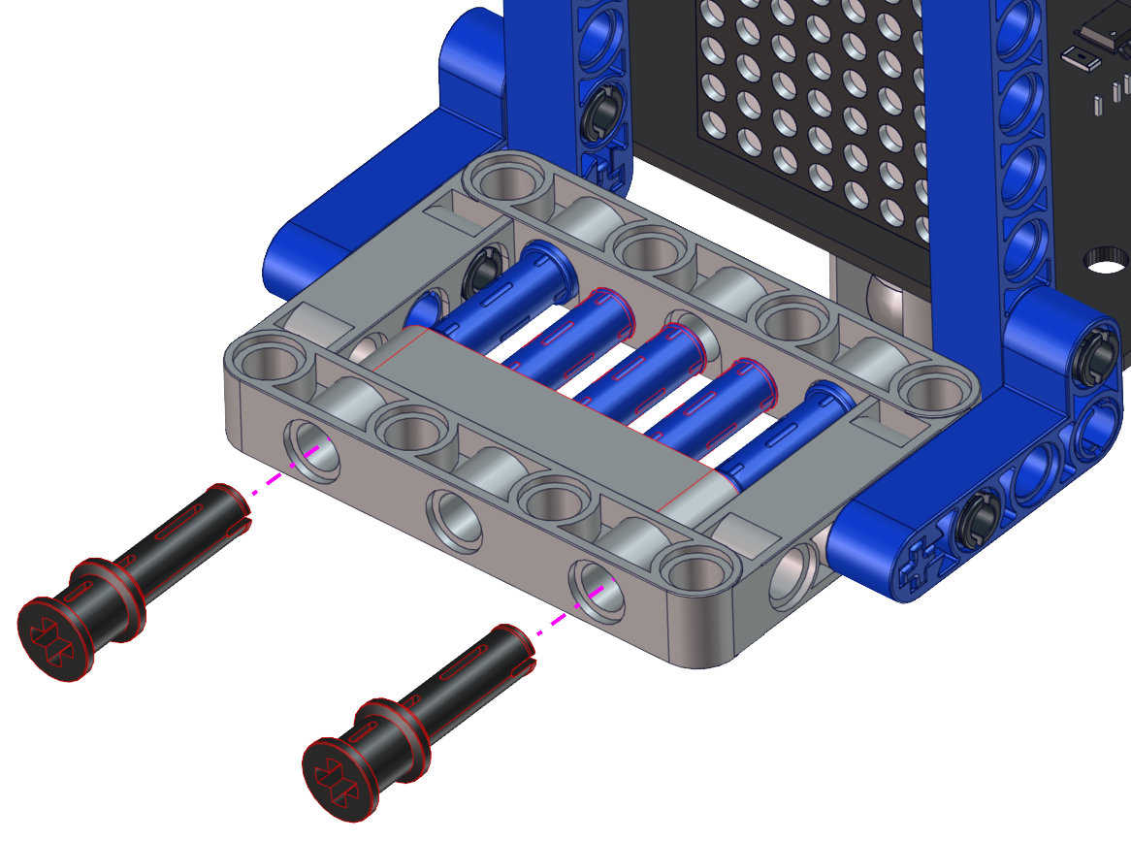

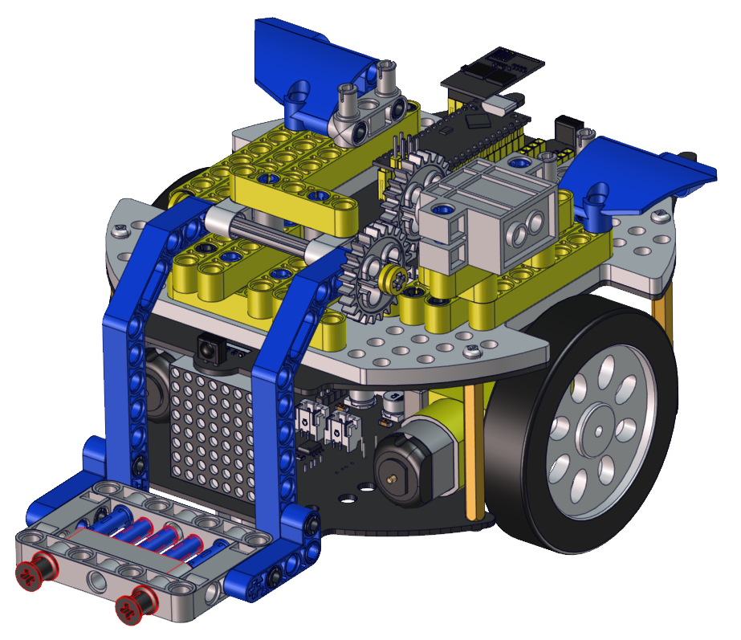

Wire up servo


